(SSIP 2.O , IIC & smartSense Technlogies)

29th April 2023 By

Mitrang Lad

Coordinators: Dr. Hetal A. Joshiara
Prof .P.R.Dave

L.D. College of Engineering, Computer Engineering Department in association with smartSense Consulting Pvt.Ltd,has organized a workshop on
“Introduction to Blockchain and web3” –A technology for research and innovation under the umbrella of SSIP 2.O and IIC. An industry expert, Mitrang Lad ,Developer of the smartSense, was the resource person. Approximately 70 students have registered for the workshop.

The workshop covered topics such as the history of the Blockchain, its architecture, the basics of Blockchain, including its structure and how it works, its benefits and limitations, and the different types of Blockchains. Additionally, the speaker also discussed the different consensus mechanisms used to secure the network and the potential use cases of Blockchain technology in various industries.

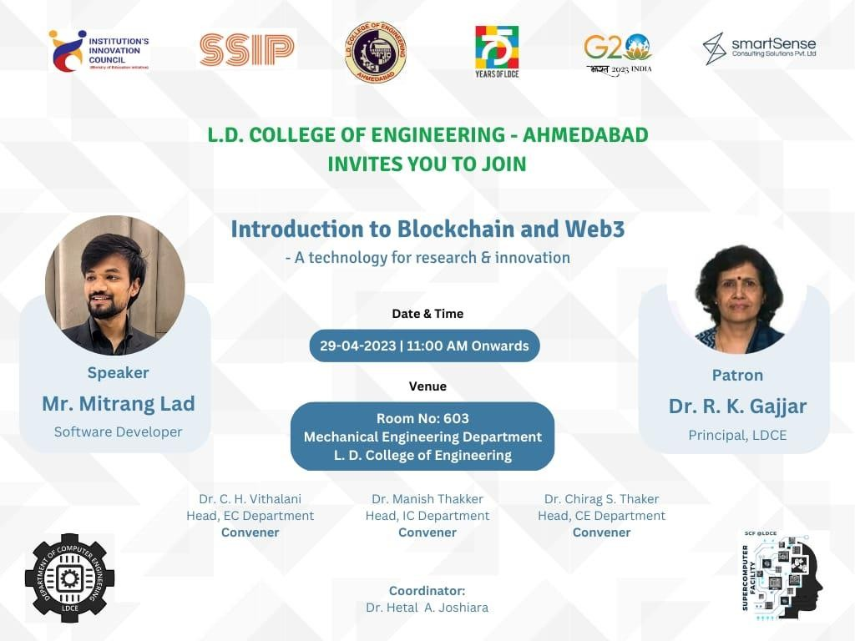

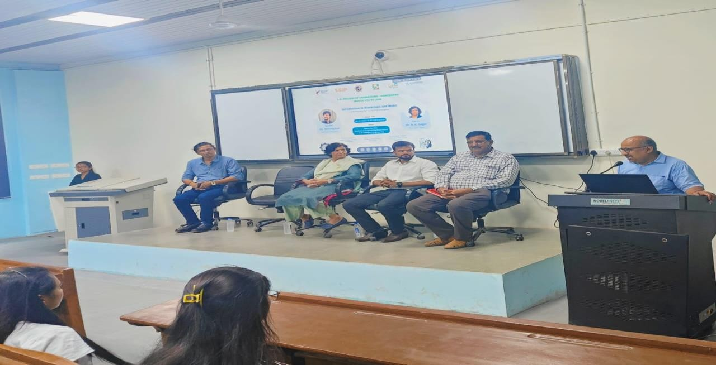

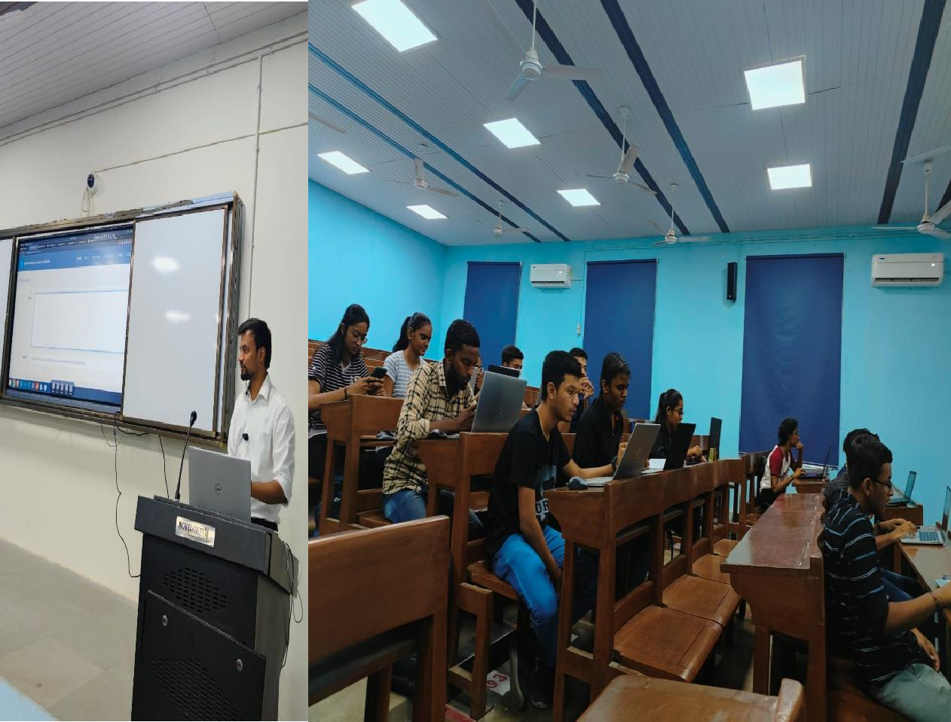

As the session was quite interactive, students learned various concepts about Blockchain technology and cleared their doubts .
Mitrang Lad taught hashing techniques that are very much used in Blockchain transactions and explained terminology in simplified language. Students performed hands-on practical and its potential use cases. The workshop also covered topics such as the basics of Blockchain, how it works, and its benefits and limitations. Participants learnt how to work with Blockchain, solidity and how to create accounts in MetaMask.

Participants also learned about the various types of Blockchains, such as public, private, and hybrid Blockchains, as well as the different consensus mechanisms used to secure the network. The workshop also included practical exercises that allow participants to build their own Blockchain applications using tools and frameworks.
Additionally, practical exercises were done that allowed participants to build their own Blockchain applications using tools and frameworks. These hands-on exercises were an excellent way to gain a deeper understanding of technology and its potential applications.
Participants gained knowledge about NFTs, EVM (Ethereum Virtual Machine) and how Blockchain is used in different fields.
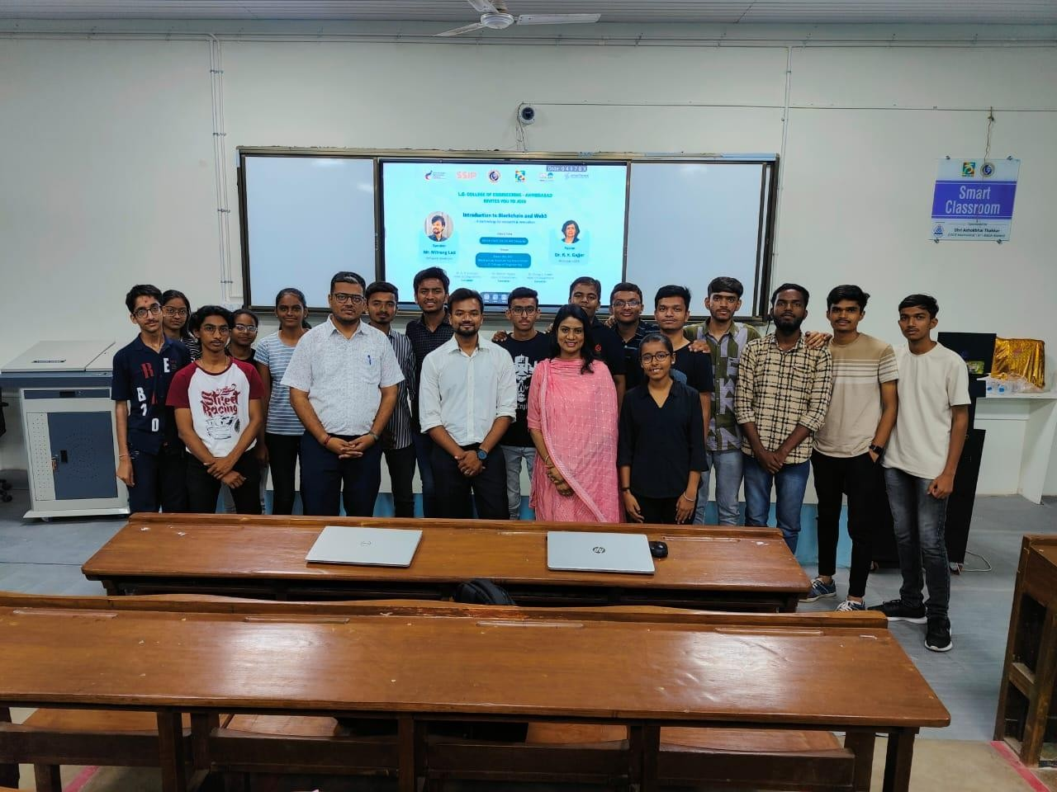

Participants also learned about the various types of Blockchains, such as public, private, and hybrid Blockchains, as well as the different consensus mechanisms used to secure the network. The workshop also included practical exercises that allow participants to build their own Blockchain applications using tools and frameworks.
Additionally, practical exercises were done that allowed participants to build their own Blockchain applications using tools and frameworks. These hands-on exercises were an excellent way to gain a deeper understanding of technology and its potential applications.
Participants gained knowledge about NFTs, EVM (Ethereum Virtual Machine) and how Blockchain is used in different fields.

